LCR CIRCUIT SIMULATION USING ARDUINO AND MATLAB

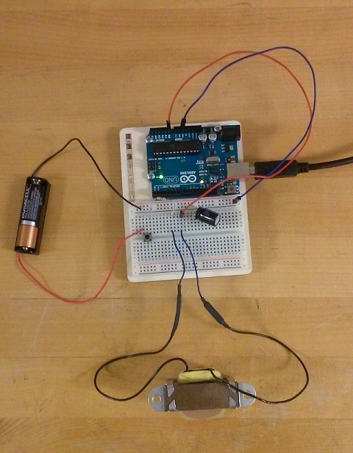

Submitted by:

Hemant Singh

Deepak Gupta

Neeraj Chauhan

INTRODUCTION

An RLC circuit (also known as a [resonant](https://en.wikipedia.org/wiki/Resonant) circuit, [tuned](https://en.wikipedia.org/wiki/Tuner) circuit, or LCR circuit) is an [electrical circuit](https://en.wikipedia.org/wiki/Electrical_circuit) consisting of a [resistor](https://en.wikipedia.org/wiki/Resistor) (R), an [inductor](https://en.wikipedia.org/wiki/Inductor) (L), and a [capacitor](https://en.wikipedia.org/wiki/Capacitor) (C), connected in series or in parallel.

An RLC circuit is called a second-order circuit as any voltage or current in the circuit can be described by a second-order [differential equation](https://en.wikipedia.org/wiki/Differential_equation) for circuit analysis.

Tuned circuits have many applications particularly for oscillating circuits and in radio and communication engineering. They can be used to select a certain narrow range of frequencies from the total [spectrum](https://en.wikipedia.org/wiki/Spectrum) of ambient radio waves. For example, AM/FM radios with analog tuners typically use an RLC circuit to tune a radio frequency. Most commonly a variable capacitor is attached to the tuning knob, which allows you to change the value of C in the circuit and tune to stations on different frequencies.

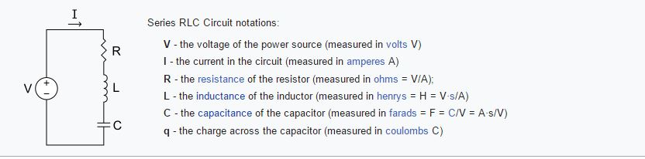

PURPOSE

The purpose of this activity is to demonstrate how to model a simple electrical system. Specifically, a first-principles approach based on the underlying physics of the circuit will be employed. The associated experiment is employed to determine the accuracy of the resulting model and to demonstrate how the individual circuit components affect the response (VOLTAGE).

**Modeling from first principles**

First we will employ our understanding of the underlying physics of the LRC circuit to derive the structure of the system model. We will term this process "modeling from first principles." In this example, we employ the variables shown below. In textbooks, the various components of a circuit are often treated as "ideal." It is important to know when such idealized models can be employed (and when they can't). In this experiment we will include the resistance contributed by our inductor (termed the inductor's *equivalent series resistance* (ESR)) because it will turn out to be significant. Specifically, we will employ a rather large inductor in order to achieve an underdamped step response. Such large inductors commonly have significant ESR, though lower ESR inductors exist if you are willing to spend more money! Capacitors also contribute resistance, but the associated ESR won't be significant for the size of capacitor we will ultimately employ. Later we will also briefly discuss the simplification of treating a transistor as an ideal switch.

(R) Resistance of the resistor

(L) Inductance of the inductor

(Req.) equivalent series resistance (ESR) of the inductor

(C) Capacitance of the capacitor

(ei) input voltage

(eo) output voltage

To begin, we assume a direction for the current and then apply Kirchhoff’s Voltage Law (loop law). Current flows from a higher potential to a lower potential, therefore, the direction of the current will be clockwise in this case (shown below).

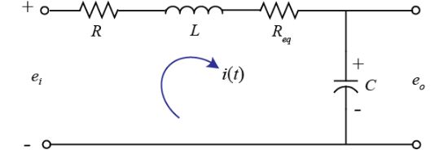

The loop law states that the sum of voltages around a closed loop must equal zero. Thus, the loop law produces the following governing equation for the circuit.

$$ e_i - iR - L\frac{di}{dt} - iR_{eq} - \frac{1}{C}\int i\ dt = 0 $$ - (1)

An alternative to an integro-differential equation model of a dynamic system is the *transfer function*. The transfer function captures the input/output behavior of a system and is derived by first taking the Laplace transform of a given integro-differential equation, while assuming zero initial conditions ($i(0) = 0$).

$$ E_i(s) - I(s)R - LsI(s) - I(s)R_{eq} - \frac{1}{Cs}I(s) = 0 $$ - (2)

Next we must perform some algebra to rearrange the above into the form of its output divided by its input. In this case, our input is $E_i(s)$ and our output is $E_o(s)$. Therefore, we must eliminate current $I(s)$ from the above since it is neither an input nor an output, and we must introduce the output $E_o(s)$ into the above equation. Solving the above equation for $I(s)$ we arrive at the following.

$$ I(s) = \frac{E_i(s)}{R+Ls+R_{eq}+\frac{1}{Cs}} $$ - (3)

Next we can recognize that the output voltage (across the capacitor) is $e_o = (1/C)\int i\ dt$. Taking the Laplace transform and again solving for $I(s)$, we arrive at the following.

$$ I(s) = \frac{E_o(s)}{\frac{1}{Cs}} $$ - (4)

Setting the two previous equations equal to one another, we can eliminate $I(s)$.

$$ \frac{E_i(s)}{R+Ls+R_{eq}+\frac{1}{Cs}} = \frac{E_o(s)}{\frac{1}{Cs}} $$ - (5)

Then re-arranging into the desired form of output divided by input, we produce the resulting transfer function model.

$$ G(s) = \frac{E_o(s)}{E_i(s)} = \frac{\frac{1}{Cs}}{R+Ls+R_{eq}+\frac{1}{Cs}} $$ - (6)

Recognizing the above as a second-order system, we can manipulate the transfer function so that it has the standard, canonical form shown below.

$$ G(s) =  \frac{\frac{1}{CL}}{s^2 + \frac{R+R_{eq}}{L}s + \frac{1}{CL}} =  \frac{\omega_n^2}{s^2 + 2\zeta\omega_ns+\omega_n^2} $$ - (7)

In this form we can see by inspection how the parameters of the circuit affect its transient response (though not the steady-state response). Specifically, the circuit components affect the parameters of the canonical second-order system in the following manner.

$$ \omega_n = \sqrt{\frac{1}{CL}} $$

(9)$$ \sigma = \zeta\omega_n = \frac{R+R_{eq}}{2L} $$

(10)$$ \zeta = \frac{\sigma}{\omega_n} = \frac{R+R_{eq}}{2}\sqrt{\frac{C}{L}} $$

These relations then relate to the characteristics of an underdamped second-order step response.

## System identification experiment

In this experiment we will record the output voltage of the LRC circuit for a step in input voltage. We then will compare the data to the response predicted by the first-principles derived model we created previously.

**Hardware setup**

Our simple LRC circuit can be implemented on a breadboard and connected to the Arduino board for recording the output voltage. There are different techniques for generating our voltage "step" input. We will specifically employ a battery as our voltage source with a push-button switch. The act of completing the circuit with the switch is equivalent to applying a step input. Driving the circuit with one of the Arduino board's Digital Outputs is problematic for a couple of reasons. For one, the Digital Output from the board provides a 5-Volt step input. This means that if the circuit is underdamped, then the output voltage will overshoot 5 Volts since the DC gain is 1. This overshoot would cause the output voltage to exceed the allowed range of the Analog Input. This could be alleviated by employing a different circuit configuration, but there is another issue. Switching the inductive load can make it difficult for the Digital Output to generate a true step, since the voltage tends to get pulled down. The same issue can arise with the 3.3 Volt source on the board. Employing a battery (AA for example) with a switch avoids these issues. The nominal voltage for most alkaline household batteries (AAA, AA, D, etc.) is 1.5 Volts.

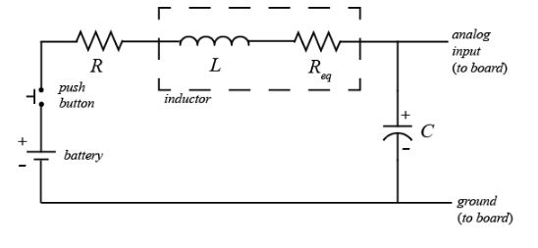

The setup of the LRC circuit and its connection to the Arduino board is shown below. The biggest challenge to achieving an underdamped response ($\zeta < 1$) that is not too fast for the Arduino board to sample ($\omega_d$ not too large) is to employ an inductor with sufficient inductance but not too much ESR. We will employ a 1 $H$ inductor with 40 $\Omega$ ESR that was relatively inexpensive to purchase. We will also employ a 510 $\mu F$ capacitor and a 10 $\Omega$ resistor, though this resistor is not necessary (make sure it is not too large). These components provide a damping ratio of $\zeta \approx 0.56$. One thing to note is that if you employ an electrolytic capacitor, its orientation matters. Specifically, if your capacitor has legs of different lengths and one leg is marked by a negative sign, then you have an electrolytic capacitor. Orient an electrolytic capacitor so that the leg marked by the negative sign connects to the lower potential part of the circuit (ground in this case). The Arduino board is employed to acquire the output voltage data from the circuit (via an Analog Input) and communicates the data to Simulink.

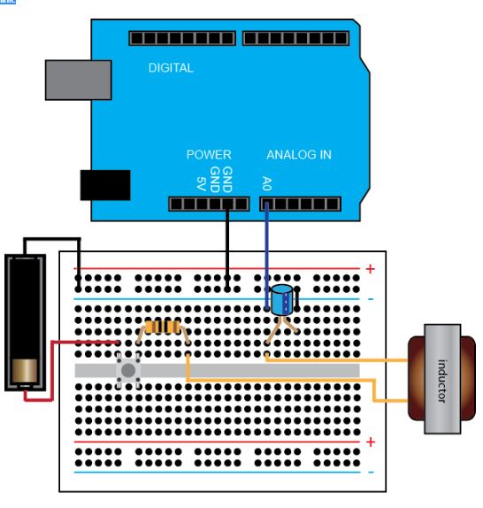

HARDWARE SETUP

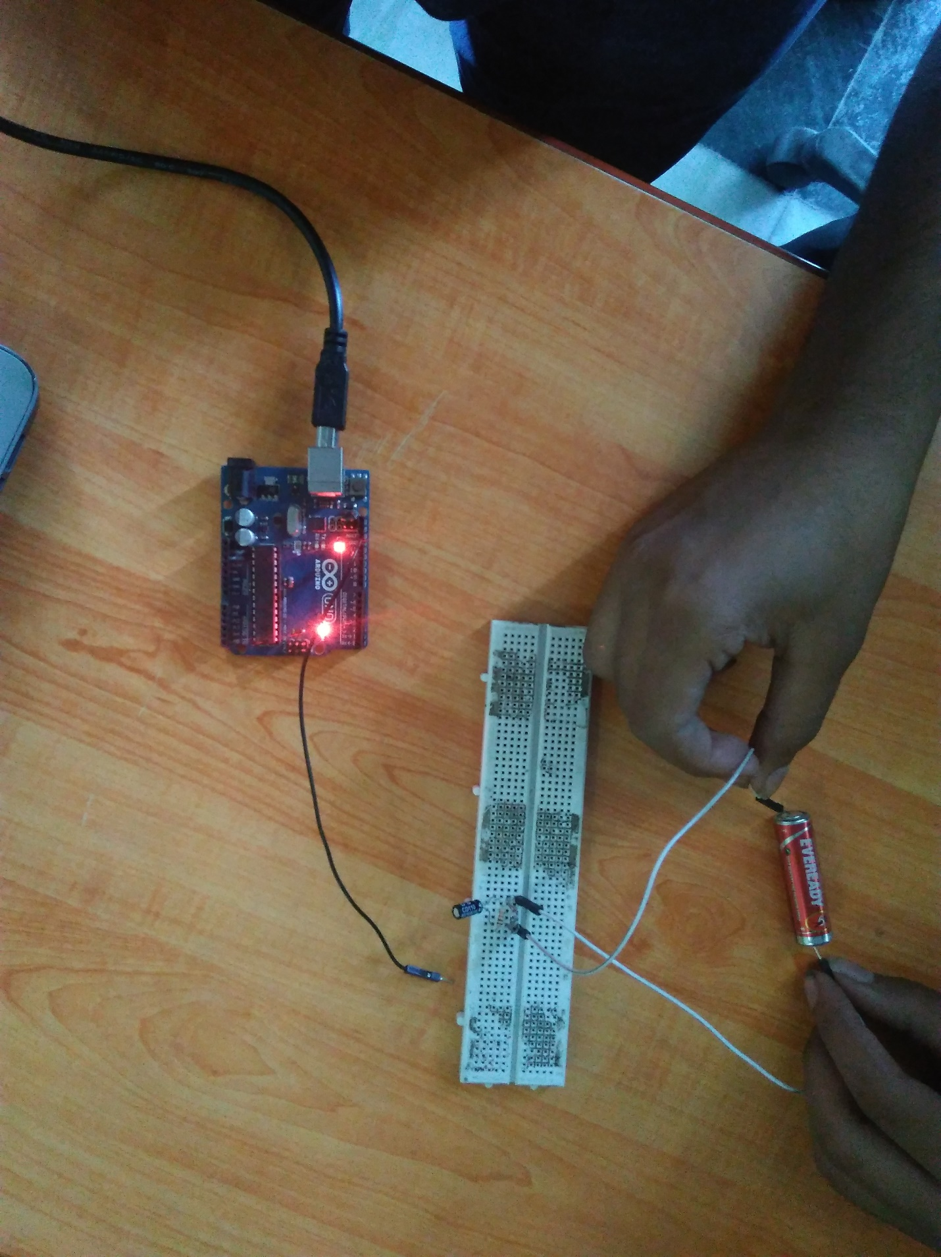

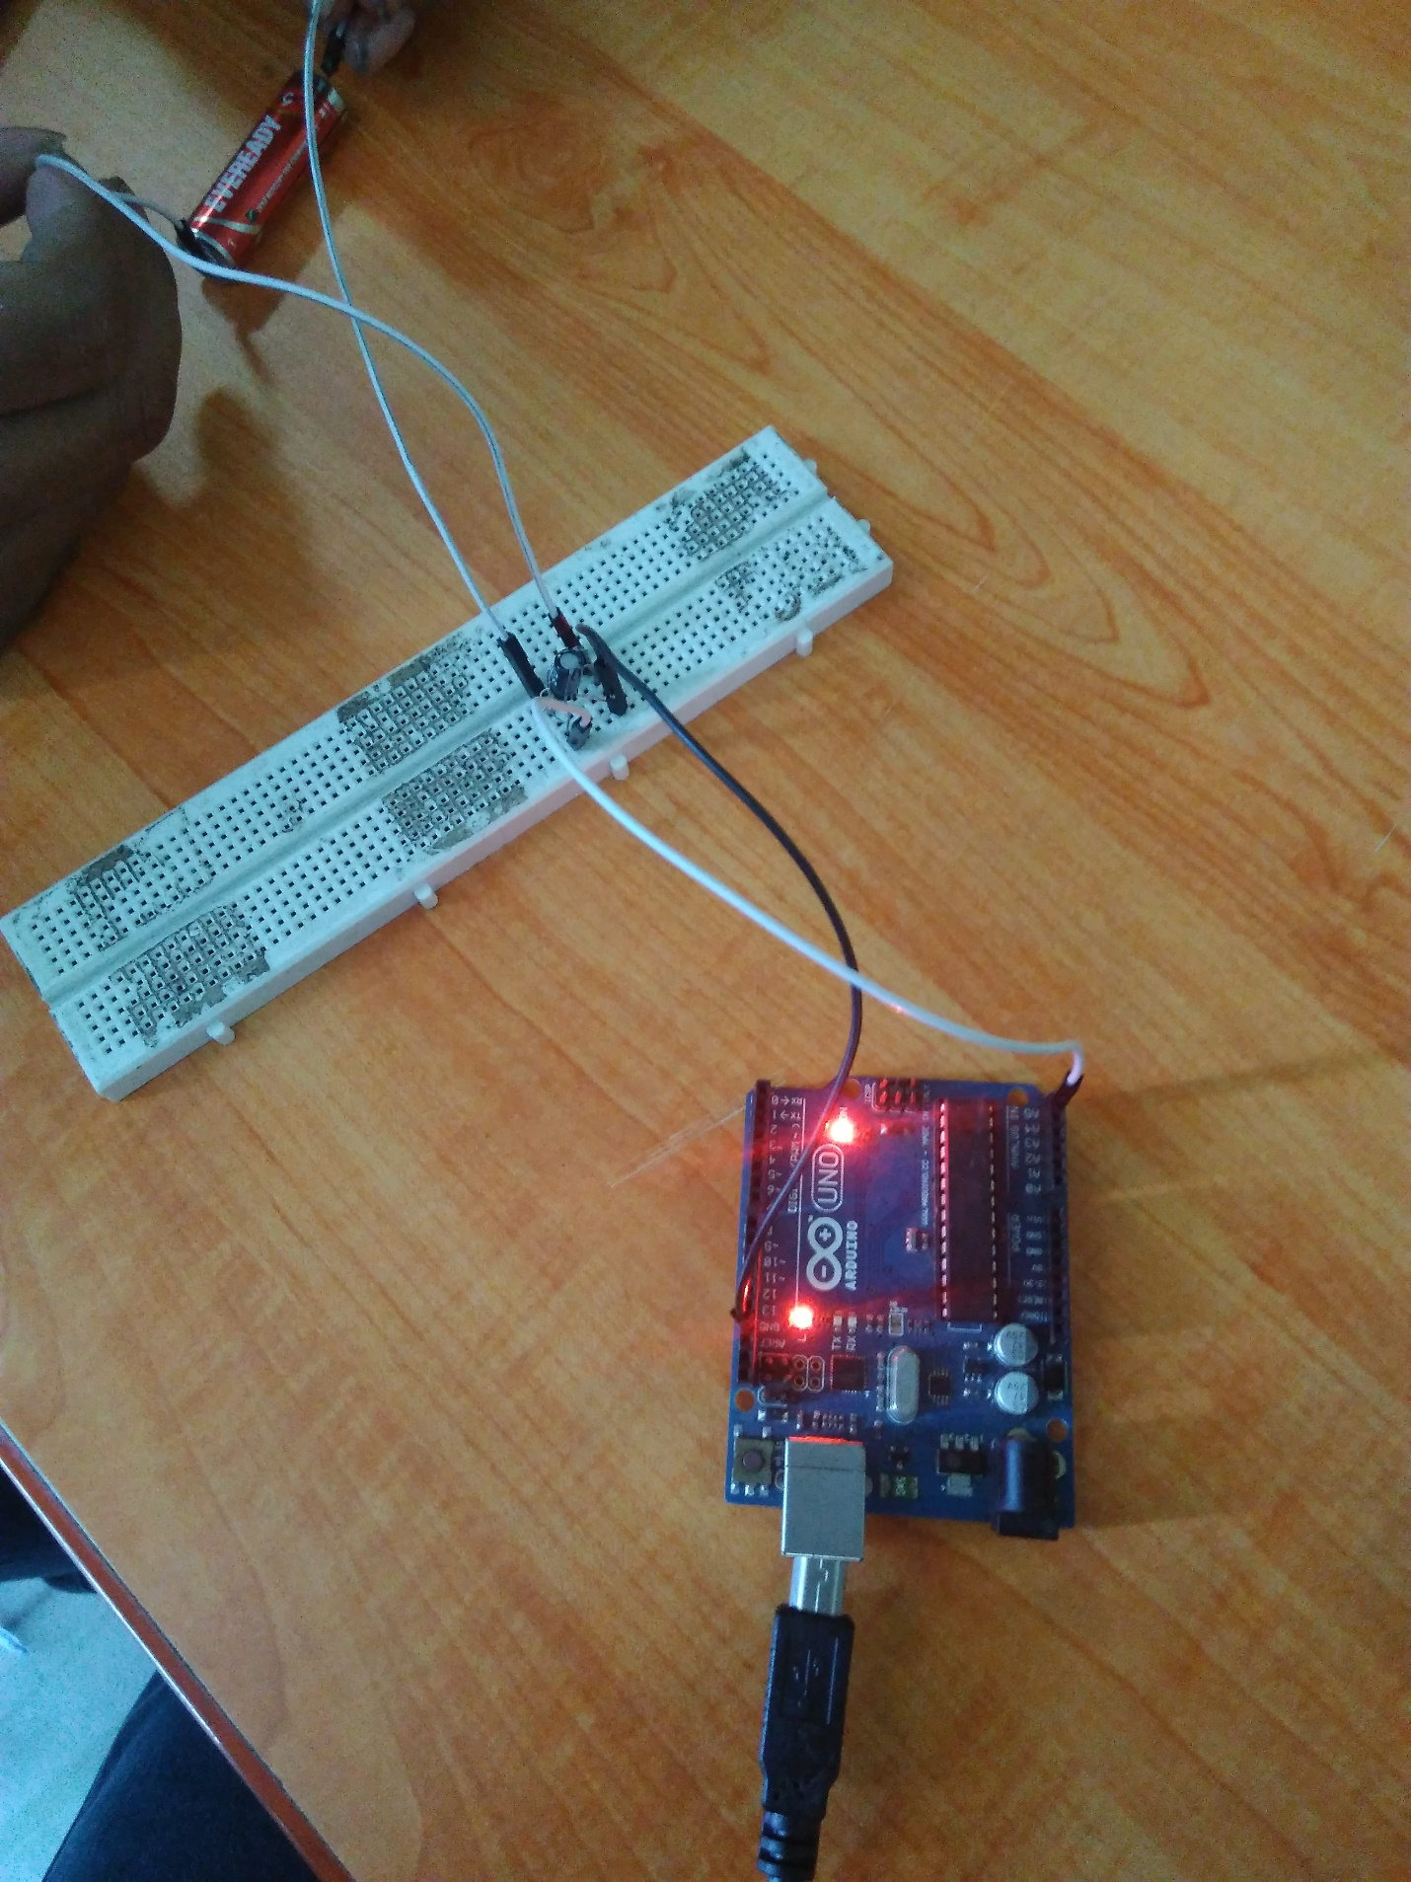

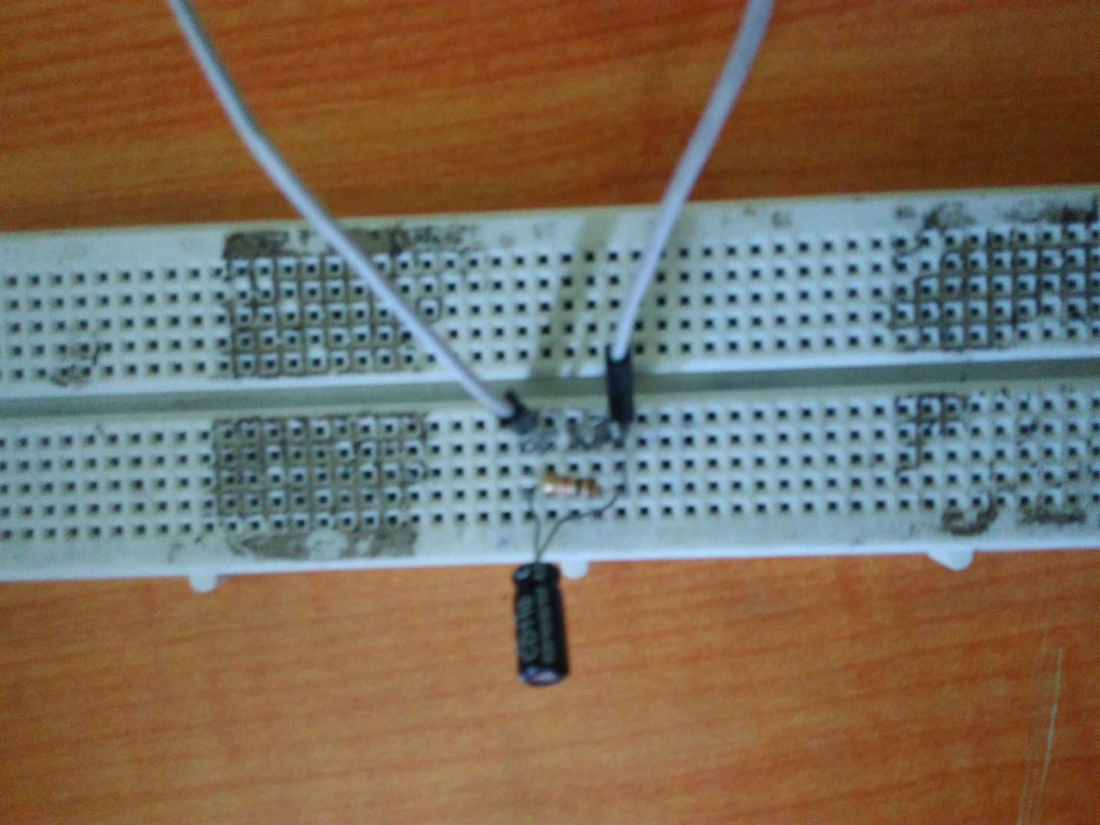

ARDUINO SIMULATION

This code reads analog voltage at pin A0.

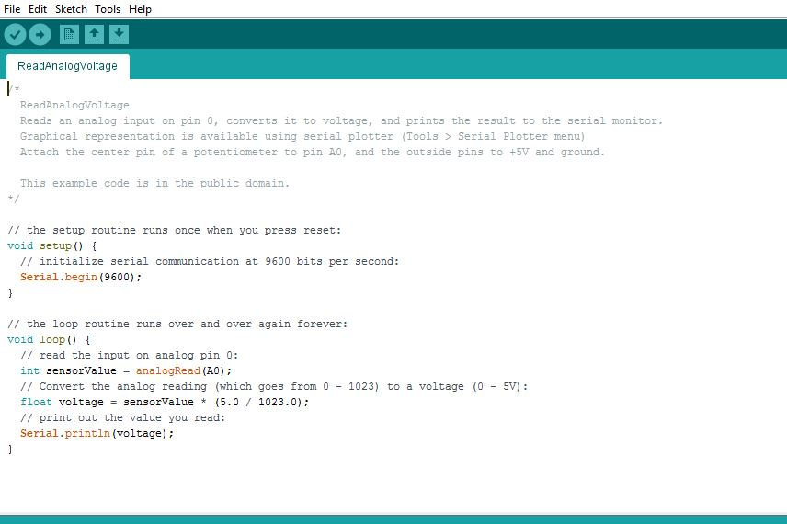

PLOTS OF VOLTAGES ACROSS INDUCTOR, CAPICITOR AND RESISTOR

Across capacitor

X axis = time

Y axis = voltage

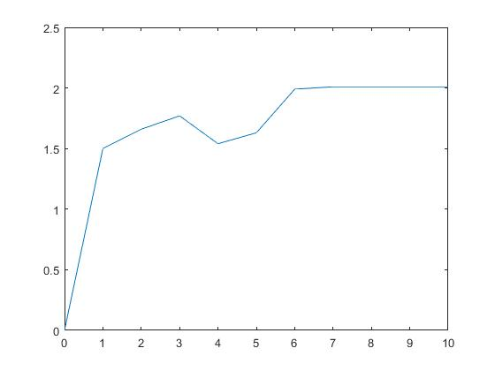

Across resistor

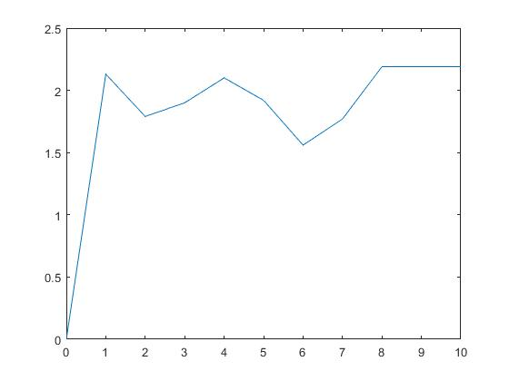

Across inductor

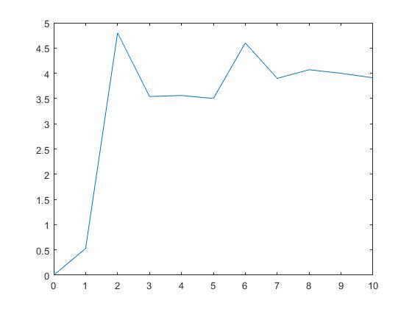

LCR CIRCUIT STEP RESPONSE

Matlab code used:

